

**Engineering Exploration Project report on**

**LIBRARY MANAGEMENT SYSTEM**

MANASVI K 160120749008

VYBHAVI BUKKA 160120749021

MAHESH REDDY JAVVAJI 160120749034

SAI MEDANSH T 160120749046

SAI SATHVIK REDDY BONTU 160120749047

Under the mentorship of **Dr. Kolla Morarjee,** Asst. Prof.

Core branch: CSE with IoT, Cyber Security with Blockchain (CSE – 5)

**Submitted to**

**Mechanical Engineering Department**

**Chaitanya Bharathi Institute of Technology (A)**

**July, 2021**

**TABLE OF CONTENTS**

**TOPIC Pg no**

ABSTRACT  **3**

ACKNOWLEDGEMENT 4

1. INTRODUCTION and MOTIVATION 5
   1. Motivation
   2. Project aims and objectives
2. Proposed System 8
   1. Existing vs proposed
3. RELATED WORKS 9
4. METHODOLY 10

Module description

1. SYSTEM DESIGN AND

IMPLEMENTATION 12

* 1. Data flow diagrams

1. RESULT ANALYSIS 23

Screen shots

1. CONCLUSION & FUTURE SCOPE 28
2. REFERENCES 29

**ABSTRACT**

Manual process of keeping student records, book records, account details, managing employee is very difficult. There are various problems also faced by the student in library such as finding any particular book, information whether book is available or not, for what time this book will be available, searching of books using ISBN number etc. Also online library systems that exist today are prone to cyber attacks but since our system is completely offline, there is no issue of malware or cyber attacks. To eliminate this manual system and problems, library management system has been developed. Library Management System will handle all the current issues faced by the students and by its admin personnel.

Library management system is a project which aims in developing a computerized system to maintain all the daily work of library. Library Management System is a system which maintains the information about the books present in the library, their authors, their published years, their ISBN number, their location and all. Overall, our LMS application is user friendly. This software takes care of all the requirements of a library and is capable to provide easy and effective storage of information related to books & users.

**ACKNOWLEDGEMENT**

We would like to express our special thanks of gratitude to our teacher, **Dr. Vamsi Inturi** and our mentor **Dr.** **Kolla Morarjee** who gave us the golden opportunity to do this wonderful report on the topic ‘Library Management System’, which also helped us in doing a lot of Research and we came to know about so many new things. We are really thankful to them.

Finally, we would also like to thank our parents and friends who helped us a lot in finalizing this project by helping us in gathering the information within the limited time frame.

**1. INTRODUCTION AND MOTIVATION**

**OBJECTIVE:**

The main objective of the Library Management system is organizing and managing the library tasks. Library is place where all kind of books are available. This is an application and only a registered user can access this application. The issues faced by today’s libraries have motivated us to do this project. Library Management system is developed to automate the task of entering the records of new book and retrieving the details of book available in the library. This system contains list of all the books present in the library. Using this system user can issue book to the library member, maintain their records, and can checks how many book are issued and how many books are available in the library. This system provides separate interface and login for librarian, students and faculties. Librarian can modify database. Using the library management system, the librarian can also fine the library member who returns the issued book after the due date.

Users can search for books and renewal books. In the proposed system, we assume that each member will be having a unique id which can be their roll number and this id can be used for the library book issue, fine payment etc. They can recommend for new books by just sending messages to the librarian from any where in the college. They can view the issue and return dates of any book and due they have to pay.

**PROBLEM STATEMENT:**

Manual process of keeping student records, book records, account details, managing employee is very difficult. There are various problems also faced by the student in library such as finding any particular book, information whether book is available or not, for what time this book will be available, searching of books using different elements etc. Also online library systems that exist today are prone to cyber attacks and require high speed internet but, since our system is completely offline, there is no issue of malware or cyber attacks. To eliminate this manual system and problems, library management system has been developed. Library Management System will handle all the current issues faced by the students and by its admin personnel.

The problem occurred before having computerized system includes:

* File lost

When computerized system is not implemented file is always lost because of human environment. Some times due to some human error there may be a loss of records.

* File damaged

When a computerized system is not there file is always lost due to some accident like spilling of water by some member on file accidentally. Besides, some natural disaster like floods or fires may also damage the files.

* + Difficult to search record

When there is no computerized system there is always a difficulty in searching of records if the records are large in number .

* + Space consuming

After the number of records become large the space for physical storage of file and records also increases if no computerized system is implemented.

* + Cost consuming

As there is no computerized system to add each record paper will be needed which will increase the cost for the management of library.

Our Library Management System has the following key features:

* Add books to the library database
* Remove books from the library
* Search for books using different elements
* Advanced search
* Student sign in
* Issue book
* Return book
* Levy fine
* View over dues

**2. PROPOSED SYSTEM:**

To solve the inconveniences as mentioned in the existing system, an Online Library is proposed. The proposed system contains the following features: The students will register them through Onlineϒ Individually each member will have his account through which he can access theϒ information he needs. Book details like authors, number of copies totally maintained by library, presentϒ available number of books, reference books, non-reference books etc. all this information can be made handy. Regarding the members designation, number of books was issued. Issue dates and returns of each member are maintained separately and fine is charged if there is any delay in returning the book. Administrator can add, update the books. Time consuming is low, gives accurate results, reliability can be improved with the help of security.

**3. RELATED WORKS**

* Gr.-06library-project-report-online : This is a report on online library management system VI semester BCA students using SQL, HTML, java script and php. This report helped us in knowing the format of report writing for projects.
* Library Management System : This is program written in python from github website. This program has given us better ideas to create our program. We used this to make some improvements to our programs.
* LMS-DBMS Report : This report is also on library management system using DBMS.

**4. METHODOLOGY**

This Library Management System consists of the following parts

**1. Adding Book to the Library**

This system accepts books from the librarian and stores all the book details in a file. The librarian can add as many books as he want to store. This is used when new books are added to the library.

**2. Deleting Book from the Library**

This feature lets the librarian to remove books from the library database by entering the id (ISBN number) of each book to be deleted. All the details of that book are deleted. This is used when the books are removed from the library.

**3. Searching Book**

This is the crucial purpose of Library management system. It provides the comfort of searching any book just in a click rather than scanning the whole library physically. It has the following parts:

* *Search by name:* This lets the user to search for a book by entering the book’s name. It tells the location of the book if it is present in the library.
* *Search by ISBN:* This lets the user to search for a book by entering the book’s ISBN (International Standard Book number) which is a unique id for every book in this world. It gives the location of the book if it is present in the library.
* *Search by author:*This lets the user to search for a book by using the name of the book’s author. It displays all the books written by that author which are present in the library.
* *Search by publisher:*User should enter the name of the publisher to search for his books. All the books’ details from this publisher which are present in the library are then displayed.
* *Search by location:*By entering the location (can be rack name or shelf name in the library) all the books at that location are displayed.

**4. Student Module:**

We put four operations under student module

* *Sign up***:** If the student is new to the library, then that student should create an account by using his roll number as unique id and any strong password as per the conditions displayed.
* *Sign in:*After creating an account, the student can sign in using his id and correct password. If the student id is not present, then we asked the student to sign up or recheck the id.
* *Borrow Book:*We accepted the ISBN number and searched for the book using the above mentioned search module. If the book is present in the library then the student can take the book and the return date is displayed.
* *Return Book:* Student can select the book which they have borrowed to return. If the book is returned late, then fine to be paid is calculated and displayed.
* *Log out:* After completing all the required operations, the student can choose to log out.

**5. View Pending Returns and borrows:**

By running this module, we displayed the list of books and students who have crossed the actual return date of those books.

**5. SYSTEM DESIGN AND IMPLEMENTATION**

**5.1. System design [1]**

Entity Relationship(ER) diagram

**Librarian**

by

**Search**

**Student**

manages

**5.2. System implementation**

**Source code :** [Click here to open the python code](https://drive.google.com/drive/folders/1WmNkXotCEimbvpJj9OKNw5L232S_4tzm?usp=sharing)

1. **Adding books to the library [2], [3] :**

We can add books to a library, by including the book name, ISBN number, author, publisher, publishing year, location and number of copies. The system accepts the books added by the librarian and we stored them in a text file. We asked the librarian to enter the details provided for entering a book into the library management system. Initially, we asked the librarian to enter the name of the book. Next, the details of ISBN number, and there is only exactly one book with each ISBN. Thereby, we asked the librarian to enter the name of the author which can be used for searching. Further, the librarian needs to enter the details of publisher and publishing year of the book. Finally, we asked the librarian to enter the details of location of the book and total number of copies of that particular which are going to be add into the library management system.The librarian can keep on adding as many books as he wants to enter. After the librarian enters all the books, these details are stored in a text file.

1. **Deleting books from the library [4]:**

We can delete books from the library, by entering the ISBN number which is unique for every book which is stored in the system. Firstly, we asked the librarian to press the button on “delete a book” to remove the book from the system. Next, the librarian enters the book ISBN number which is unique for every book. The librarian should keep on entering the book number (ISBN number) for deleting those books.

While deleting books from the system, the librarian has to enter only the details of ISBN number. After successfully entering the ISBN number, the books are deleted from the library data base and the user can no longer access those books.

**3. Search Operations[2]**

The main purpose of the Library Management System is to reduce the manual work and searching is the most tedious work because it is tedious to search the whole library for the book we need. So searching for book using the search operations provided here will make it much easier. The Search class contains all search methods. We provided the following search operations.

1. *Search by name:*

This is the most common search operation. We asked the user to enter the name of the book that he wants to search for. Then we compared this search query with all the book names in the file containing the book details. It even takes care of the case of the letters while comparing. If the search query matches the book then all the details of the book are stored in a list which is returned to the display_books method.

1. *Search by ISBN number:*

Every book in this world has a unique 10 digit or 13 digit number known as ISBN (International Standard Book Number) number. We asked the user to enter the ISBN number of the book that he wants to search for. Then we compared this search query with all the ISBN numbers in the file containing the book details. If the search query matches the book then all the details of the book are stored in a list which is returned to the display_books method.

Flowchart for search by name and ISBN

Start

Read next book

name/ISBN

False

Is Search= bookname/ISBN

True

End

Return the list

Return False

False

True

is end of file

Add book details to list

1. *Search by author:*

There can be one or more books written by an author. We asked the user to enter the author name that he wants to search for. Then we compared this search query with all the author names in the file containing the book details. If the search query matches the author name of any book then we stored all the details of that book in a list. Then we added this list to main list which contains lists of all matched books. This continues until the end of file is reached. Then we returned this main list to the display_books method.

1. *Search by publisher:*

There can be one or more books published by a publisher. We asked the user to enter the publisher name to fetch the details of books published by that publisher in the library. Then we compared this search query with all the publisher names in the file containing the book details. If the search query matches the publisher name of any book then we stored all the details of that book in a list. Then we added this list to main list which contains lists of all matched books. This continues until the end of books file is reached. Then we returned this main list to the display_books method.

1. *Search by location:*

Location can be rack number or any other name given to places in library. We asked the user to enter the location name to fetch the details of all the books from that location in the library. Then we compared this search query with all the location names/numbers in the file containing the book details. If the search query matches the location name of any book then we stored all the details of that book in a list. Then we added this list to main list which contains lists of all matched books. This continues until the end of books file is reached. Then we returned this main list to the display_books method.

Flowchart for search by author, publisher and location

Start

False

Read next author/ publisher/location name

Return main list

End

Add this list to main list

Add book details to list

True

True

is Search=author/ publisger/location

False

is end of file

**4. Advanced Search and displaying book results[1], [8]**

Based on the search operations, we called the corresponding search method from the Search class. The following operations have been done for searching and displaying the output.

1. *Search by name*

* When the user selects this operation, we asked the user to enter the name of the book to search for. Then this name is converted into lower case letters and the search query is passed to the byname( ) method.
* If a list containing book details is returned then that entire book’s details along with the book location are displayed for the user.
* If the book is absent then we displayed that book with exact name is not present in the library and advanced search is used which checks the books containing similar words as in search query.
* This advanced search method byname( ) returns a list containing all the books obtained by advance search. Then we displayed these details in a tabular form saying that similar matches are found but exact book is not found.

1. *Search by ISBN number*

* When the user selects this operation, we asked the user to enter the ISBN number of the book to search for. Then we passed this number to the byname( ) method as a search query.
* If a list containing book details is returned then that entire book’s details along with the book location are displayed for the user.
* If the book is absent then we displayed that book with given ISBN number is not present in the library.
* Advanced search is not possible for ISBN numbers.

1. *Search by author*

* When the user selects this operation, we asked the user to enter the author name to search for his books. Then this name is converted into lower case letters and the search query is passed to the byauthor( ) method.
* If a list containing list of books’ details is returned then that entire books’ details are displayed for the user.
* If the book written by that author is absent then we displayed that books written by author with exact name are not present in the library and advanced search is used which checks the author names containing similar words as in search query.
* This advanced search method byauthor( ) returns a list containing all the books obtained by advance search. Then we displayed these details in a tabular form saying that similar matches are found for the author name but books with exact author name are not found.

1. *Search by publisher*

* When the user selects this operation, we asked the user to enter the publisher name to search for his books. Then this name is converted into lower case letters and the search query is passed to the bypublisher( ) method present in Search class.
* If a list containing list of books’ details is returned then that entire books’ details are displayed for the user.
* If the book published by that publisher is absent then we displayed that books published by given publisher with exact publisher name are not present in the library and advanced search is used which checks all the publisher names in the file containing similar words as in search query.
* This advanced search method bypublisher( ) returns a list containing all the books obtained by advance search. Then we displayed these details in a tabular form saying that similar matches are found for the publisher name but books with exact publisher name are not found.

1. *Search by location*

* When the user selects this operation, we asked the user to enter the location in the library to check books at the location or rack. Then this name is converted into lower case letters and the search query is passed to the bylocation( ) method present in Search class.
* If a list containing list of books’ details is returned then that entire books’ details are displayed for the user.
* If no book is at given location then we displayed that no books at that location exist in library. Advance search is not present for this operation.

**5. Student Sign up [6]**

If the student is new to library then we asked the student to sign up. If that id is already present, that student is redirected to sign in. We asked to set password with following conditions - At least 1 small letter a to z, at least 1 capital A to Z ,at least 1 number, at least 1 special character.

If student enters other than this we kept on asking student to enter correct password until he enters correct These passwords are changed to cipher text and then they are encrypted into special symbols which cannot be understood by other users.. We used different encodings for different students. Even if 2 students set the same password they are encoded and stored differently in the text file.

**6. Student Sign in**

We asked the student to enter his id**.** We compared the Id with all other ids**.** If id did not match, we asked the student to sign up if he is new or recheck the id and reenter it**.** This continues until he enters the correct password**.** Then if id matched we asked him to enter his password**.** If student enters wrong password we kept on asking student to enter correct password. This continues until he enters correct password.If password matches we asked him to select the operations he wants to perform.

**7. Issue Books [7]**

* After logging in to the student account, the student can borrow book for 15 days by entering the ISBN of the book.
* Then we searched the library for this book.
* If the book exists then we allowed the student to borrow the book.
* If the book is absent the library then we displayed a message saying that the book is not available in the library.
* The student cannot borrow more than 3 books at any point of time.
* Return date is calculated based on issue date which is 15 days from the date of borrowing and it is displayed to the student.
* All these details that are ISBN, issue date and return date are written to a text file which is named after the id of the student.
* All the borrowers are also stored in a text file.

**8. Return Books [5]**

* Here the student can return the books that he has borrowed
* We displayed all the books borrowed by the student.
* The student has to select the books that he wants to return.
* Today’s date is compared with the actual return date.
* If current day’s date is too late than actual return date then the we asked student to pay a fine of Rs. 10 per day after the actual return date.
* Then that book is removed from the student’s text file.
* If all the books have been returned then we deleted the text file with the name of that student. We also removed the student’s id from the borrowers file.

**9. Log Out**

* The student can perform the above mentioned operations as many times as he want.
* After this the student can log out to secure his account.
* This enables other students to log in and no one can do any wrong activities with the previous account after it is logged out.

**10. View Late Borrowers**

* If the librarian selects this operation, the all the students’ details who have crossed the deadline for returning.
* All the details that are student id, actual return date and number of due days are displayed in the tabular format
* The current day’s date is compared with the actual return date of every borrower. If the limit is exceeded, then those students are displayed.

**6. RESULT ANALYSIS**

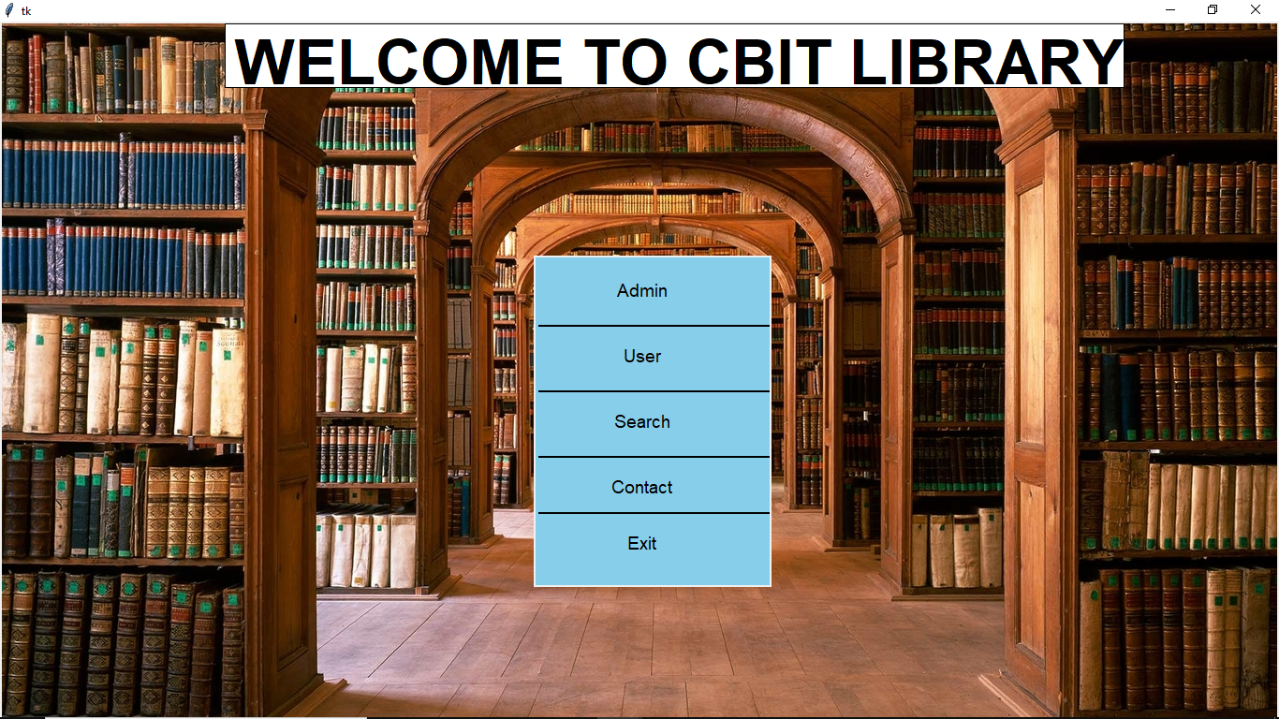

This is the main page from which all operations can be performed. 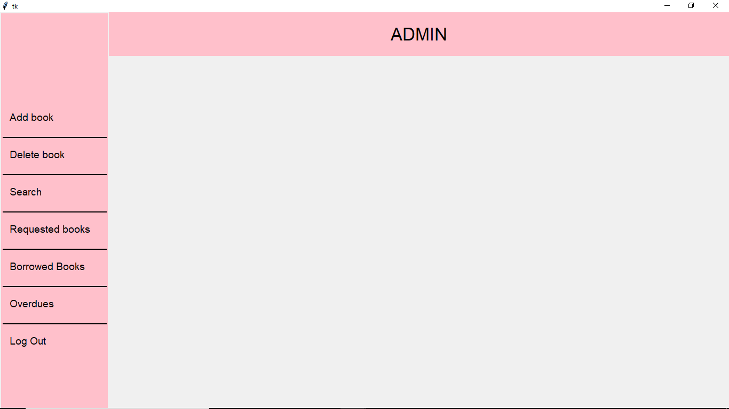

This is the Admin window which appears only after logging in. Admin can perform all his operations by selecting from the menu on the left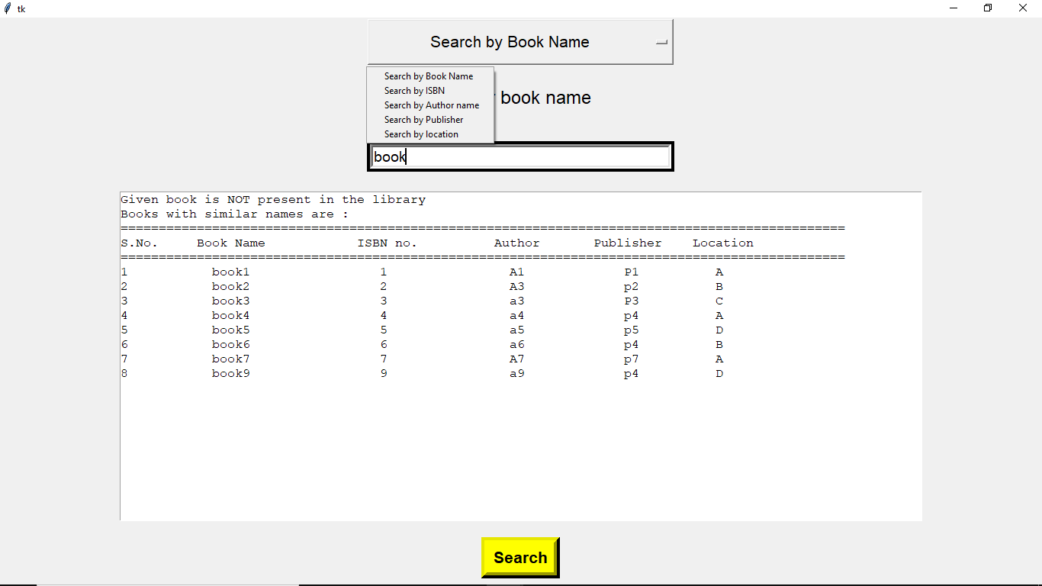

This is the window for search and advanced search operations which can be accessed through main window, admin window or student window. Different search operations can be selected from the drop down list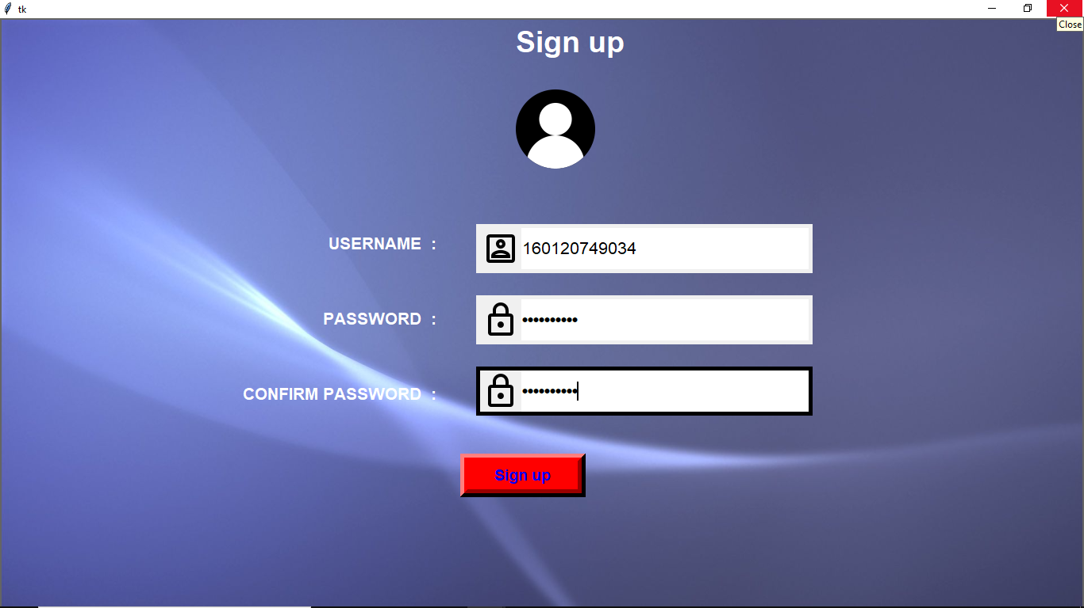

This is signup page for new students

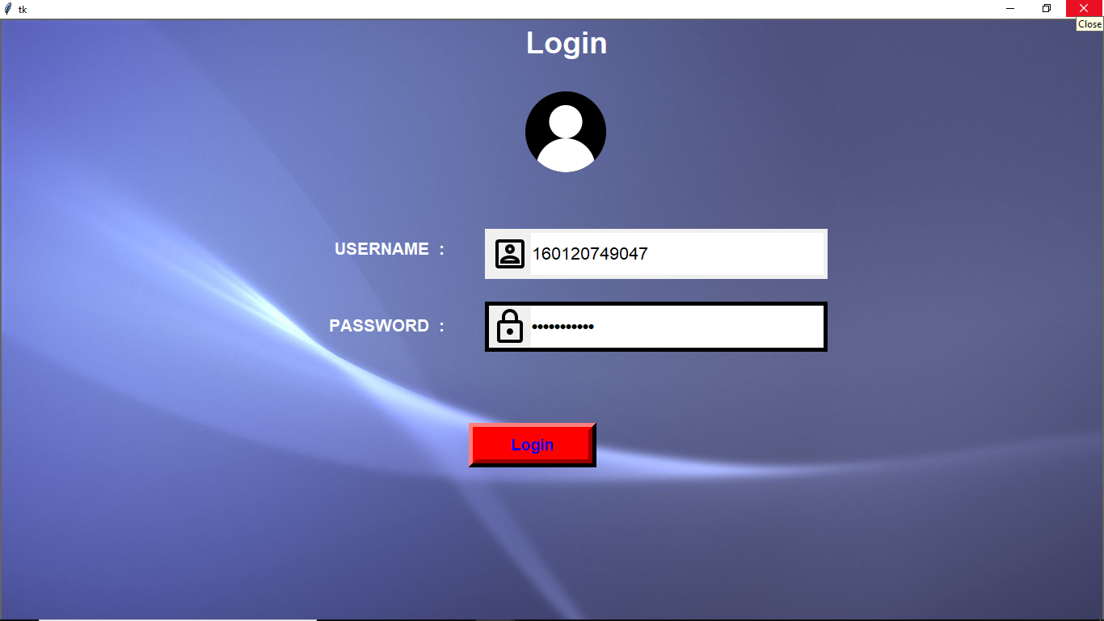

This login page is common for both Admin and user. Only after logging in, they can perform their operations

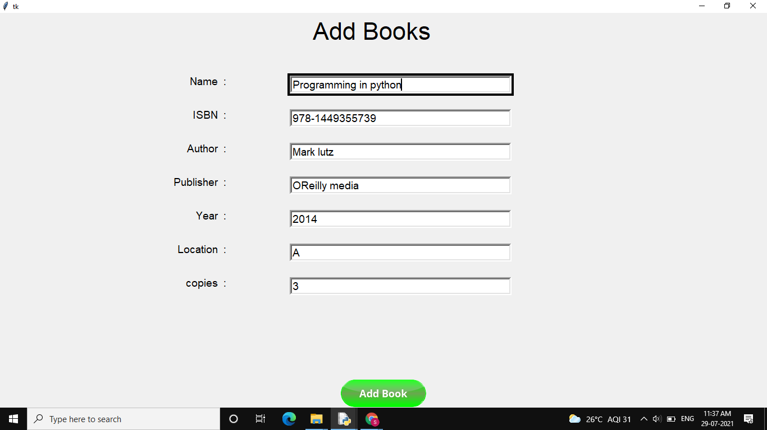

Only admin can add new books to the library. All entries are validated. Similarly, there is another window for removing books from library

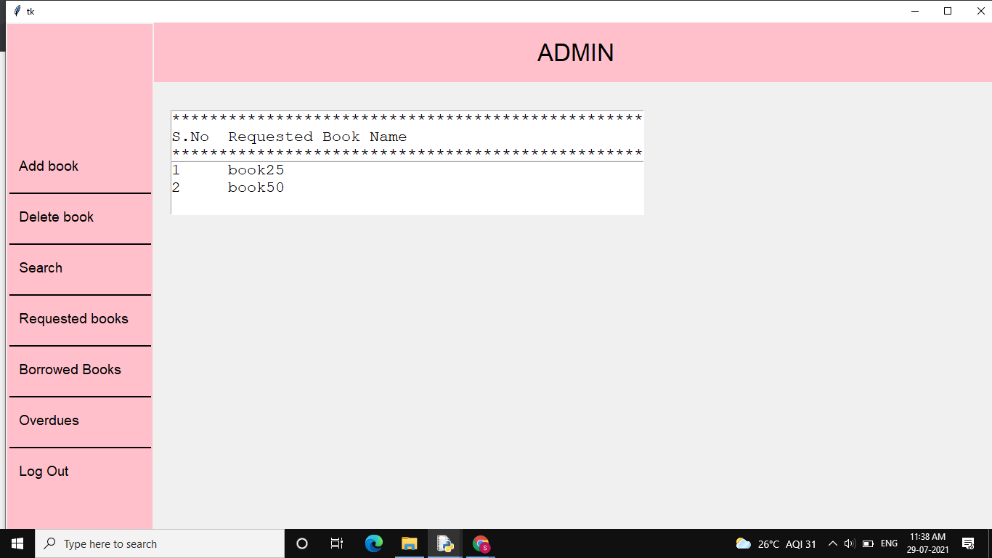

On clicking ‘requested books’, the books requested by students are displayed here.

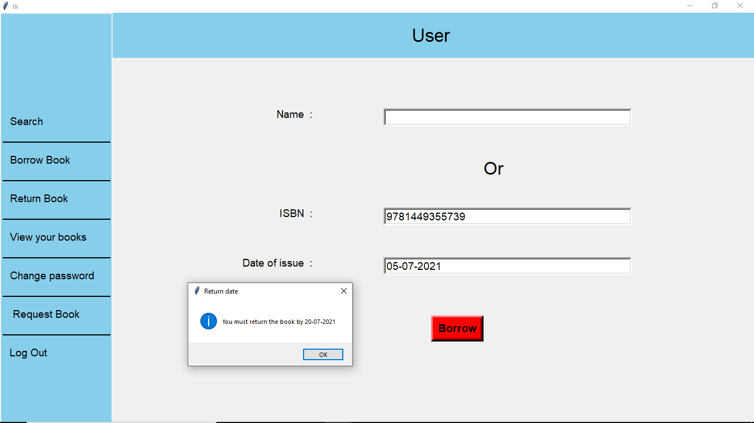

User can borrow book for 15 days using book name or ISBN, then the return date is displayed

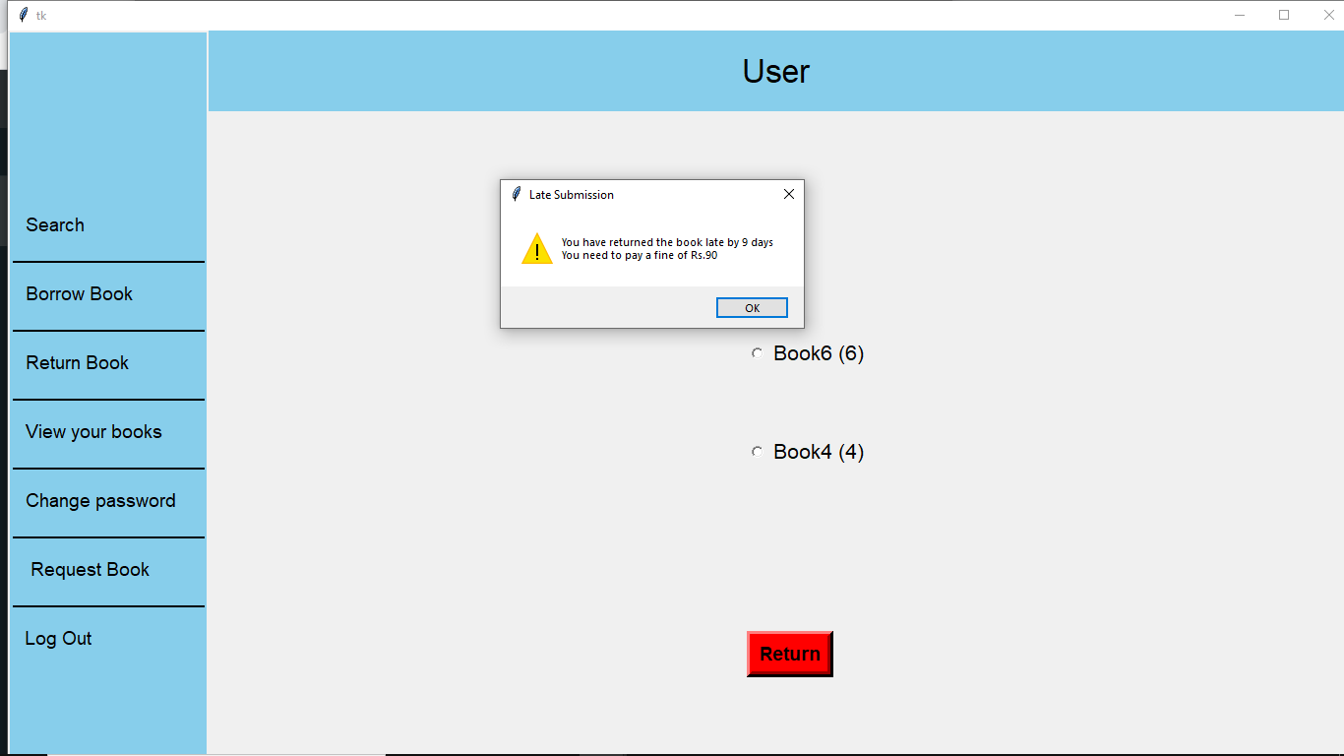

This window is for returning the book by selecting one of the books. If book is returned late, the user is fined as shown in the warning window

There are many other operations like requesting books, log out, different types of search operations and advanced search operations, viewing books borrowed by the user, change password and displaying warnings and errors for wrong entries which are not covered with screenshots under this chapter.

**6. Conclusion and Future Scope**

The Library Management System has been developed to benefit the students as well as the staff of the library. It automates and digitalizes many processes. It secures every account by encrypting the passwords and this encryption is different for every user. The main intention of this project is to reduce the manual work which is tedious and prone to errors. This system has all the features that are required by a library.

There is a future scope of this facility that many more features such as online lectures video tutorials can be added by teachers as well as online assignments submission facility, a feature Of group chat where students can discuss various issues of engineering can be added to this project thus making it more interactive more user friendly and project which fulfills each users need in the best way possible.

Also the security and authentication can be increased in the future by implementing fingerprint or facial recognition technologies. This system can even be taken online. Using DBMS for this will make the tasks even simpler.

**7. References**

1. All the related works and literature were of great help
2. Programming in python 3 text book by Mark Summerfield
3. Mark Lutz “Learning Python”, O’Reilly Media Inc., 5th Edition
4. <https://stackoverflow.com/questions/4710067/how-to-delete-a-specific-line-in-a-file>
5. <https://www.geeksforgeeks.org/>
6. <https://www.tutorialspoint.com/python/index.htm>
7. <https://www.programiz.com/python-programming>
8. <https://stackoverflow.com/>